**Assignment 8: Implement Backward Chaining Algorithm**

**Problem Statement**

The objective of this assignment is to implement the backward chaining algorithm for reasoning in a rule-based system, aiming to verify whether a specific goal can be deduced from a given set of facts and rules.

**Objectives**

* To apply the backward chaining algorithm for deriving conclusions by working from the goal back to the facts.
* To verify if a specific goal can be inferred using available rules and facts.
* To use the backward chaining approach for goal-directed reasoning.

**Theory**

**What is Backward Chaining?**

Backward Chaining is a reasoning method that starts with a specific goal or query and works backward to determine which facts or rules support that goal. This approach is particularly useful in systems where specific answers are sought from a broader knowledge base.

**Methodology**

1. Define Facts and Rules:

* Facts: Represent known information about the system.
* Rules: Logical implications where each rule specifies how a conclusion can be derived from conditions (premises).

1. Start from the Goal:

* The algorithm begins with the goal (desired conclusion) and tries to prove whether the goal is valid by verifying the premises of relevant rules.

1. Recursively Apply Rules:

* For each premise of a rule, check if it can be proven either by known facts or by applying other rules that lead to that premise.

1. Repeat Until Goal is Proven or No Further Rules Apply:

* Continue this process recursively until the goal is either proven (derived from facts) or no more rules can be applied to infer the goal.

**Working Principle / Algorithm**

Here’s a simple outline of the Backward Chaining algorithm:

1. **Initialize the Knowledge Base**:
   * Represent known facts and inference rules. For example:
     + **Facts**: F1,F2,…,FnF_1, F_2, \ldots, F_nF1​,F2​,…,Fn​
     + **Rules**: If AAA then BBB.
2. **Define the Goal Query**:
   * Specify the goal you want to prove (e.g., GGG).
3. **Check for Known Facts**:
   * If GGG is a known fact, return true.
4. **Search for Relevant Rules**:
   * For each rule in the knowledge base, check if GGG matches the conclusion of any rule.
   * If a matching rule is found, recursively apply the algorithm to its premises.
5. **Return the Result**:
   * If all premises are satisfied (i.e., proven true), then GGG is also true. If any premise fails to be satisfied, backtrack and try other rules.

**Advantages**

* **Goal-Directed Reasoning:** Backward chaining focuses only on proving the goal, making it efficient for problems where the goal is specific.
* **Efficiency for Small Problem Spaces:** In scenarios with limited rules and facts, backward chaining can efficiently derive conclusions.
* **Selective Application of Rules:** Only the relevant rules leading to the goal are applied, avoiding unnecessary inferences.

**Disadvantages / Limitations**

* **Complexity for Large Rule Sets**: If there are many possible rules or intermediate goals, backward chaining can become complex and inefficient.
* **Difficulty Handling Multiple Goals**: It can be challenging to handle multiple interconnected goals, as backward chaining is focused on a single goal.
* **Not Suitable for All Problem Types**: Backward chaining may struggle with problems where a wide exploration of the knowledge base is required.

**Diagram**

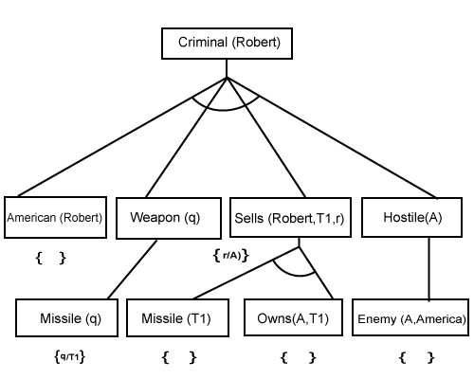

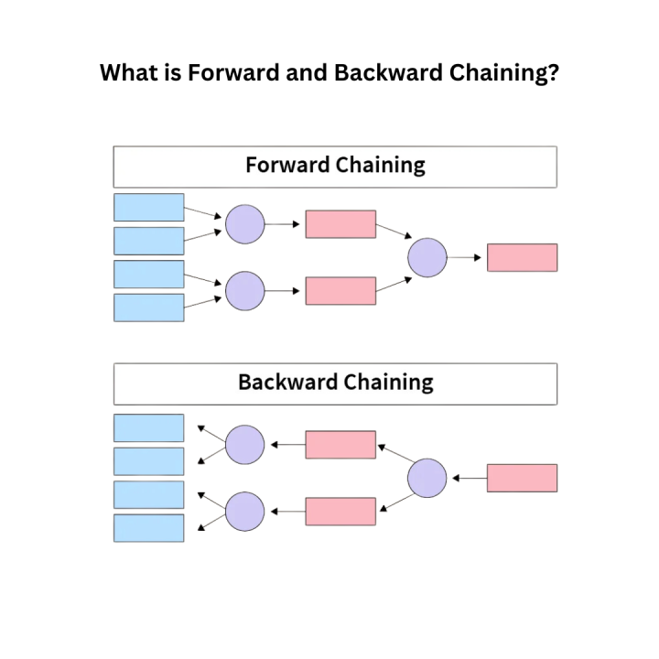

**Conclusion**

Backward chaining is a powerful technique for goal-driven reasoning, effectively answering specific queries from a knowledge base. It emphasizes the necessity of known facts and rules while focusing on proving desired conclusions.